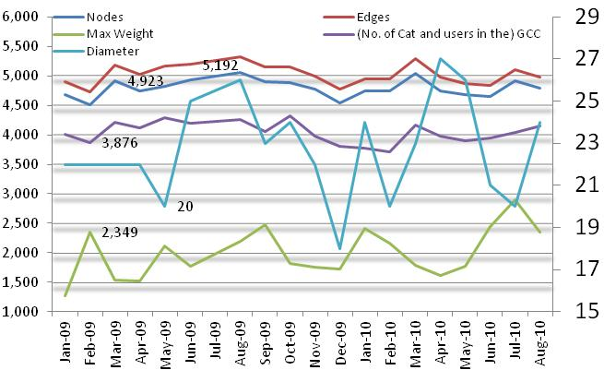
Figure 1: Topological parameters of active users’ – behavior over 19 months of activity (see Table 8 in the Appendix)

