Appendix

Table 1 – Frequency of AIDS news coverage along the 10 Arabic media outlets in 2014

Media outlets | Total no. of news stories | Frequency
- CNN | 20,562 | 16
- BBC | 16,516 | 20
- France24 | 23,084 | 23
- RT | 38,408 | 32
- Al Jazeera | 33,124 | 28
- SkyNews | 33,097 | 10
- Al Hayat | 27,182 | 13
- Al Arabi | 60,209 | 22
- Al Sharq Al Awsat | 39,866 | 13
- Al Arab | 27,044 | 13
Total | 298,533 | 190 (0.06%)

Figure 1 – Google searches for five STDs in Arabic from 2004-2015
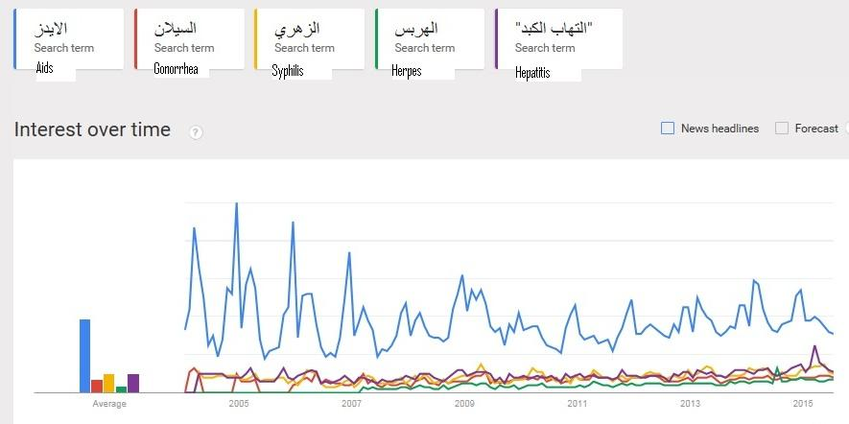

Figure 2 – Monthly distribution of AIDS coverage by all Arabic media outlets, “AIDS” hashtag, and “AIDS” Wikipedia in 2014
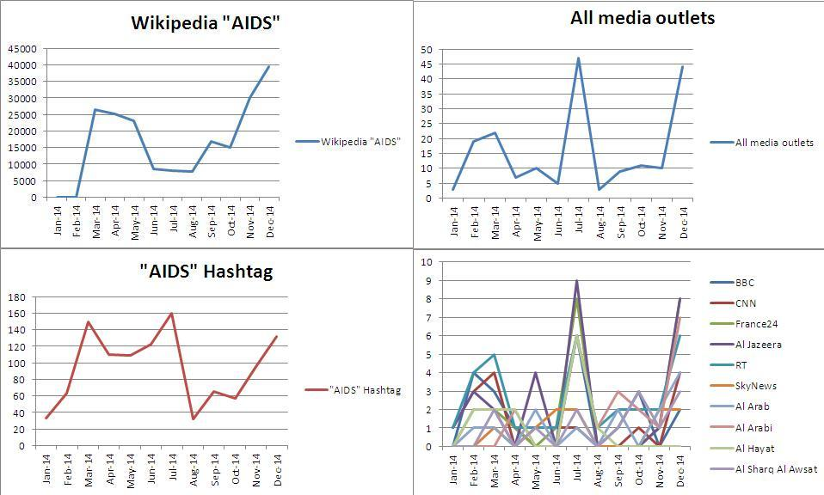

Figure 3 – Google search in Arabic in 2014 for AIDS and its symptoms and treatment
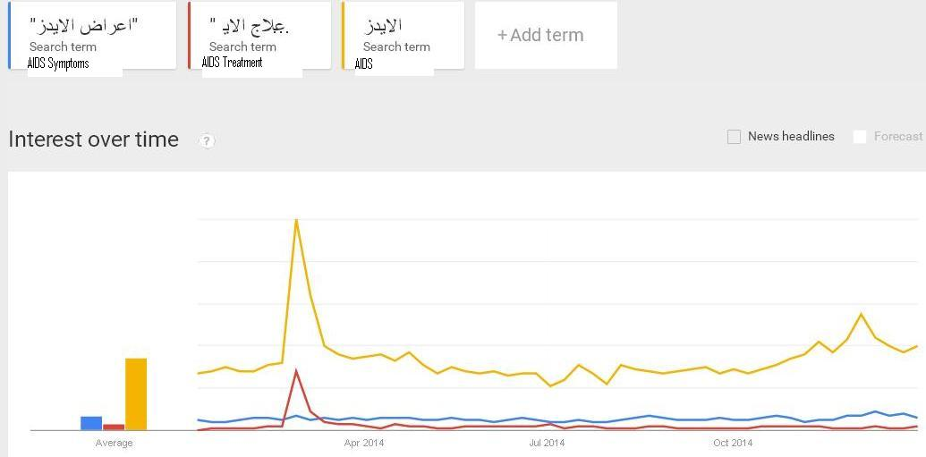

Figure 4 – Top cities distribution based on their STDs Google searches in Arabic from 2004-2015
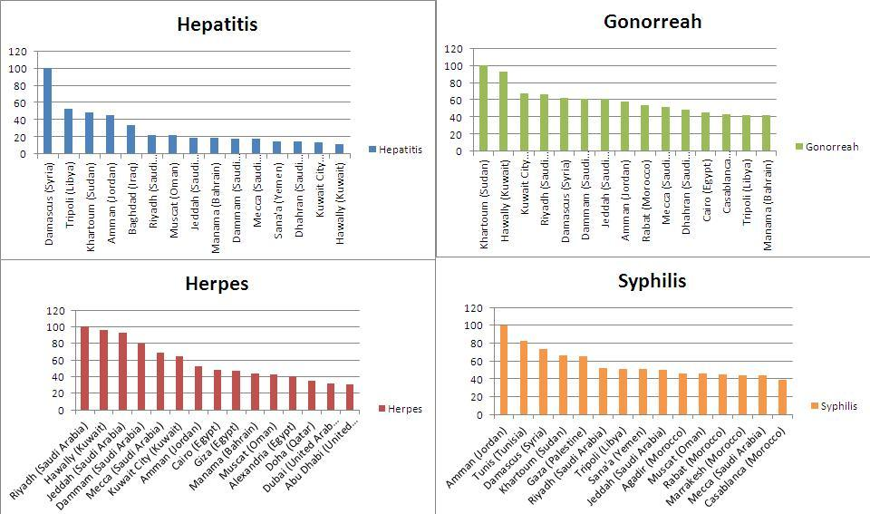

Figure 5 – Top cities based on their AIDS symptoms and treatment searches in Arabic from 2004-2015
